**Practice Exercise – Easy**

**Directions (Q Nos. 1 − 3):** *Go through the chart given below and solve the questions based on it.*

The GCB matrix is a graphical representation of the growth rates of the market and the market size for various groups of any company. The GCB matrix of all the product groups of the company ABCD Ltd. is as shown below

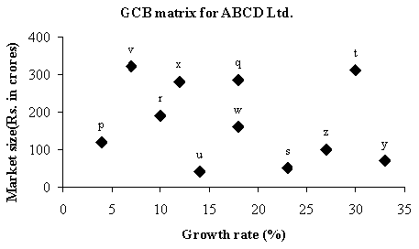

The median growth rate of the company is defined as the simple average of the growth rates of the products showing the least and the highest growth rates. Similarly, the median market size is defined as the simple average of the market size of the products having the smallest and the largest market sizes.

All products with growth rate less than median growth rate and market size less than median market size are called Dogs. Those products with growth rate more than median growth rate and also market size more than median market size are called Starts. The rest of all product groups are called Questions.

1. How many product groups of ABCD Ltd. would be called Dogs?

a. 1

b. 2

c. 3

d. 4

2. How many product groups of ABCD Ltd. would be called Stars?

a. 1

b. 2

c. 3

d. 4

3. How many product groups of ABCD Ltd. would be called Questions?

a. 5

b. 6

c. 7

d. 8

**Directions (Q Nos. 4 − 7):** *Go through the charts given below and solve the questions based on it.*

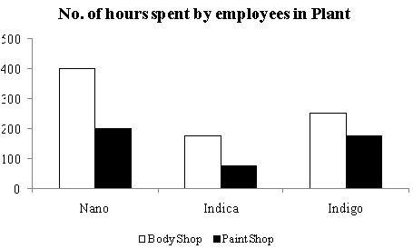

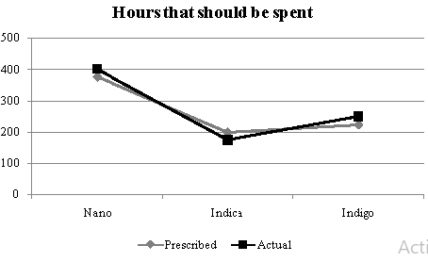

Paint shop is done always outside. All the values are the multiples of 10.

4. Which of the following gives as many hours as those spent on Indigo?

a. Paint shop - Nano

b. Body shop - Indigo

c. Paint shop - Nano and Indica

d. Body shop - Nano and Indica

5. What percentage of the hours is spent in body shop?

a. 32.12%

b. 45.69%

c. 64.84%

d. 81.02%

6. The total number of hours spent paint shop is nearest to which of the following:

a. The prescribed hours for Nano

b. The Body shop hours for Nano

c. The sum of the Prescribed and Actual hours spent on Indigo

d. The total hours spent on Indica

7. If the total hours in the plant were to be 300 hours, then which of the following would account for approximately 150 hours?

a. Indigo

b. Nano

c. Indica

d. Body shop - Nano and Indica

**Directions (Q Nos. 8 − 12):** *Go through the data set given below and solve the questions based on it.*

The following graph captures the demand and supply situation of Rin supreme bars in a town Patna over the years 2003-2008.

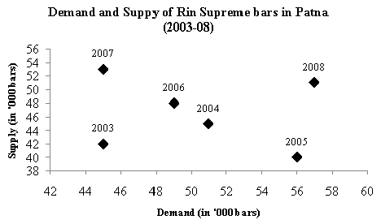

8. For who many years, the supply was not less than the demand?

a. 0

b. 1

c. 3

d. 7

9. If the price of one bar of Rin supreme is directly proportional to the ratio of demand to supply, in which year, in the time period 2003-2008, was the price of a bar the highest?

a. 2007

b. 2005

c. 2006

d. 2008

10. Over the time period of 2003-2008, in how many years did both demand and supply show a similar trend (*i.e*., either both increased or both decreased) over the previous year?

a. 1

b. 2

c. 3

d. 4

11. Patna had an inventory of 20,000 bars at the start of 2003. In which year was the deficit of bars the highest? [Deficit is defined as demand minus available quantity and available quantity is supply of year plus the inventory. In a year where availability is less than the demand, the demand goes unsatisfied in that year and is not carried forward. Excess availability over demand goes into inventory]

a. 2008

b. 2007

c. 2006

d. 2005

12. The demand and supply given above is to be re-drawn using the line chart with the year along the *X*-axis and the demand and supply along the *Y*-axis (same scale being used for both demand and supply). At how many distinct points would the two lines cut?

a. 0

b. 1

c. 2

d. 3

**Directions (Q Nos. 13 − 17):** *Go through the radar diagram given below and solve the questions based on it.*

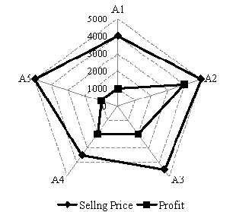

The above given radar diagram gives the selling price and profit of five persons *A*1, *A*2, *A*3, *A*4 and *A*5.

Selling Price − Cost Price = Profit

13. Which article has maximum cost price?

a. *A*2

b. *A*3

c. *A*4

d. None of these

14. Which article has minimum cost price?

a. *A*2

b. *A*4

c. *A*5

d. None of these

15. Selling price of *A*2 increases by 20% however cost price of *A*2 increases only by 15%, by what percentage profit of *A*2 has increased?

a. 5%

b. 12.5%

c. 15%

d. None of these

16. For which article the cost price as a percentage of selling price is maximum?

a. *A*1

b. *A*3

c. *A*5

d. None of these

17. For how many articles is the profit more than 30%?

a. 1

b. 2

c. 3

d. More than 3

**Directions (Q Nos. 18 − 20):** *Answer the questions based on the following information.*

Each point in the graph below shows the profit and turnover data for a company. Each company belongs to one of the three industries: textile, cement and steel.  **[CAT 2003]**

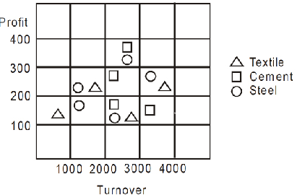

18. For how many companies does the profit exceed 10% of turnover?

a. 8

b. 7

c. 6

d. 5

19. For how many steel companies with a turnover of more than 2000 is the profit more than 300?

a. 0

b. 1

c. 2

d. 7

20. An investor wants to buy stock of only steel or cement companies with a turnover more than 1000 and profit exceeding 10% of turnover. How many choices are available to the investor?

a. 4

b. 5

c. 6

d. 7

**Directions (Q Nos. 21 − 24):** *Answer the questions based on the following information.*

The data points in the figure below represent monthly income and expenditure data of individual members of the Ahuja family (■), the Bose family (□), the Coomar family (●), and the Dubey family (○). For these questions, savings is defined as **[CAT 2010]**

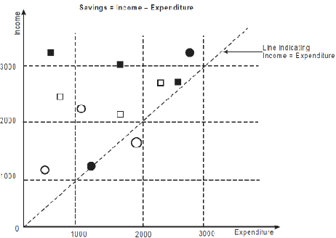

21. Which family has the lowest average income?

a. Ahuja

b. Bose

c. Coomar

d. Dubey

22. Which family has the highest average expenditure?

a. Ahuja

b. Bose

c. Coomar

d. Dubey

23. Which family has the lowest average savings?

a. Ahuja

b. Bose

c. Coomar

d. Dubey

24. The highest amount of savings accrues to a member of which family?

a. Ahuja

b. Bose

c. Coomar

d. Dubey

**Directions (Q Nos. 25 − 28):** *Go through the chart given below and solve the questions based on it.*

The cumulative bar graph shows the different scores of five shooter in a particular competition. There are 4 points which are recorded in this chart - Highest score, Career Average. The sum of all these scores is represented as 100% in the chart below. Some of the absolute score values are given in the table represented below.

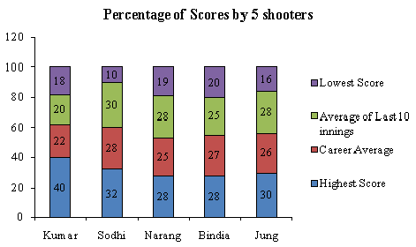

|  |  |  |
| --- | --- | --- |
| **Absolute Score** | | |
|  | **Highest Score** | **Career Average** |
| Kumar | 600 |  |
| Sodhi | 480 |  |
| Narang |  | 57 |
| Bindia | 395 |  |
| Jung | 498 |  |

25. What is the lowest score of Sodhi?

a. 450

b. 300

c. 250

d. 150

26. What is the average of last 10 innings of Kumar?

a. 300

b. 270

c. 330

d. 600

27. What is the highest score of Narang?

a. 54

b. 38

c. 75

d. 84

28. What is the approximate career average of Jung?

a. 398

b. 432

c. 438

d. 444

**Practice Exercise – Medium**

**Directions (Q Nos. 1 − 6):** *Answer the questions based on the following information.*

The following bar chart gives the growth percentage in the number of households in middle, upper-middle and high income categories in the four regions for the period between 1987-88 and 1994-95.

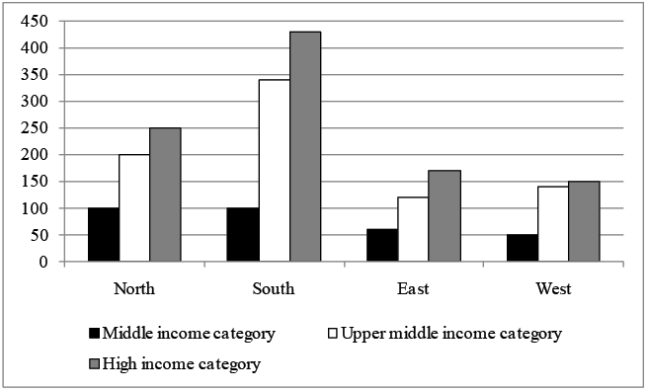

|  |  |  |  |
| --- | --- | --- | --- |
|  | Number of households in 1987-88  (in thousands) | Average household income in 1987-88 | Growth in average household income (1994-95 over 1987-88) |
| Middle income | 40 | Rs. 30,000 | 50% |
| Upper-middle | 10 | Rs. 50,000 | 60% |
| High income | 5 | Rs. 75,000 | 90% |

1. Which region showed the highest growth in number of households in all the income categories for the period?

a. North

b. South

c. West

d. None of these

2. What was the total household income in northern region for upper-middle class?

a. Rs. 50 lakh

b. Rs. 500 million

c. Rs. 300 million

d. Cannot be determined

3. What is the percentage increase in total number of households for the northern region (upper-middle) over the given period?

a. 100%

b. 200%

c. 240%

d. Cannot be determined

4. What was the average income of the high-income group in 1987-88?

a. Rs. 75,000

b. Rs. 25,000

c. Rs. 2,25,000

d. Cannot be determined

**Directions (Q Nos. 5 − 6):** *The numbers of households in each category were equally distributed in all the regions.*

5. The ratio of total income for the high-income category to the upper-middle class increased by how much percentage in the given period?

a. 20%

b. 36%

c. 25%

d. Cannot be determined

6. The average income for the northern region in 1987-88 was:

a. Rs. 37,727

b. Rs. 37,277

c. Rs. 35,000

d. Cannot be determined

**Directions (Q Nos. 7 − 10):** *Answer the questions based on the following information.*

The profitability of a company is defined as the ratio of its operating profit to its operating income, typically expressed in percentage. The following two charts show the operating income as well as the profitability of six companies in the financial years (F.Ys.) 2001-02 and 2002-03. **[CAT 2003]**

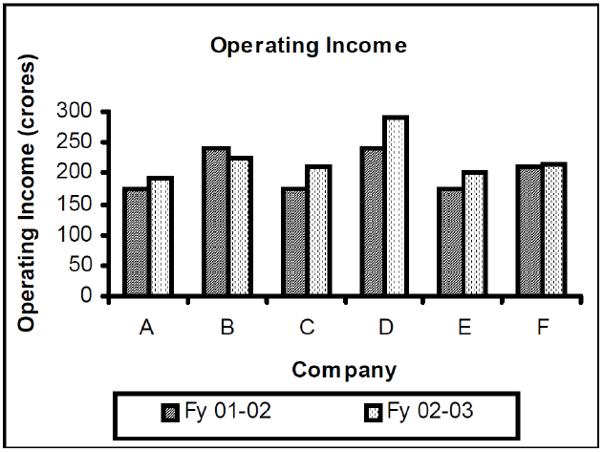

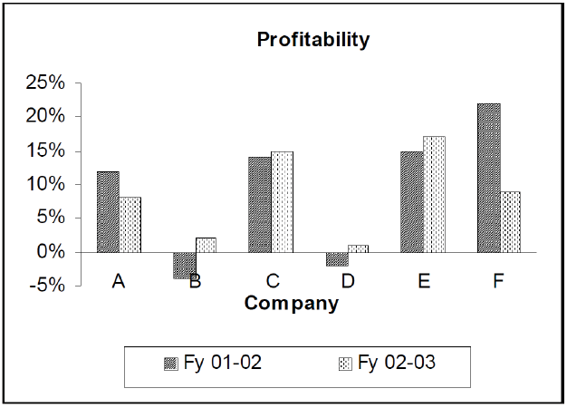

The operating profits of four of these companies are plotted against their respective operating income figures for the F.Y. 2002-03, in the third chart given below.

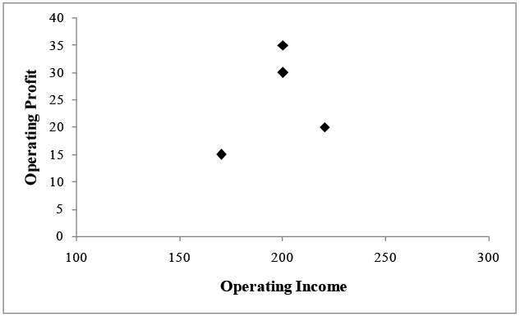

7. Which of the following statements is NOT true?

a. The company with the third lowest profitability in F.Y. 2001-02 has the lowest operating income in F.Y. 2002-03

b. The company with the highest operating income in the two financial years combined has the lowest operating profit in F.Y. 2002-03

c. Companies with a higher operating income in F.Y. 2001-02 than in F.Y. 2002-03 have higher profitability in F.Y 2002-03 than in F.Y. 2001-02

d. Companies with profitability between 10% and 20% in F.Y. 2001-02 also have operating incomes between 150 crore and 200 crore in F.Y. 2002-03

8. Which company recorded the highest operating profit in F.Y. 2002-03?

a. A

b. C

c. E

d. F

9. What is the approximate average operating profit, in F.Y 2001-02, of the two companies excluded from the third chart?

a. –7.5 crore

b. 3.5 crore

c. 25 crore

d. Cannot be determined

10. The average operating profit in F.Y. 2002-03 of companies with profitability exceeding 10% in F.Y. 2002-03, is approximately

a. 17.5 crore

b. 25 crore

c. 27.5 crore

d. 32.5 crore

**Directions (Q Nos. 11 − 14):** *Go through the charts given below and solve the questions based on it.*

Chart (1) represents the total number of applications received by five companies *PIMA*, *PIMB*, *PIMC*, *PIMK* and *PIML* in the year 2007. Chart (2) represents the total number of applications selected and total number of applications on waiting list. Total number of applications received = Number of applications selected + number of applications on rejected + number of applications on waiting list.

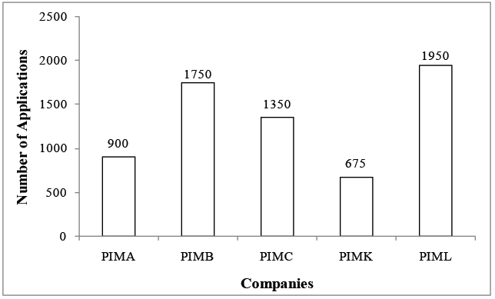

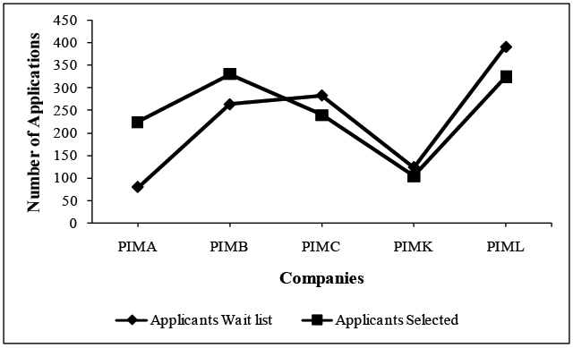

For companies *PIMA* and *PIMB*, number of applicants selected is more than number of applicants on waiting list.

Use approximations wherever necessary.

11. Which company has the minimum ratio of number of rejected applicants to the total number of applicants received?

a. *PIMA*

b. *PIMB*

c. *PIMC*

d. *PIML*

12. In company *PIML*, 29% of selected applicants are rejected due to health reasons and 36% of the waiting list applicants are selected. Then, the percentage of selected applicants ahs increased/decreased by:

a. 10.5% increase

b. 14.5% increase

c. 10.5% decrease

d. 14.5% decrease

13. Which company has maximum ratio of selected to rejected applicants, if the number of applicants selected and the number of applicants on waiting list are interchanged?

a. *PIML*

b. *PIMA*

c. *PIMC*

d. *PIMB*

14. For company *PIMA*, 12.5% of the waiting list applicants are finally selected and 25% of the rejected candidates are added to the waiting list. Now, what percentage of applicants are on the waiting list?

a. 22.22%

b. 32.11%

c. 24.33%

d. 26.12%

**Directions (Q Nos. 15 − 19):** *Go through the charts given below and solve the questions based on it.*

The following charts show the sectorwise percentage break-up of Rs. 300 million, which is the revenue of a BAGA Corp. with a workforce of 6000 people, 70% of this workforce is working on an average contributing to the revenue.

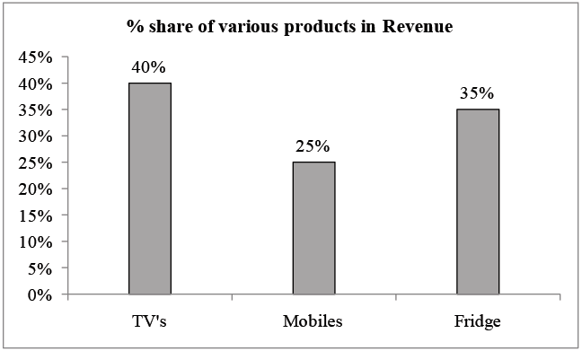

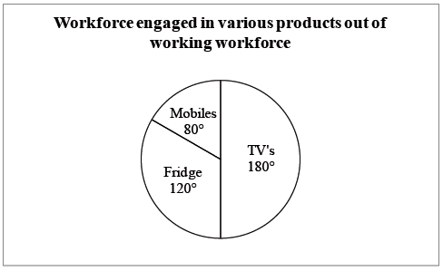

Productivity is defined as the average amount contributed to the revenue per employee in that group or products.

15. Which of the following groups/product has the lowest productivity?

a. Fast bowlers

b. Medium pacers

c. Spinners

d. Non-working workforce

16. What is the approximate difference in the number of persons involved in the mobiles and the TV'sv products?

a. 700

b. 1400

c. 2100

d. 4200

17. What percentage of the company's total workforce is engaged in the fridge product?

a. 19%

b. 31.22%

c. 23.33%

d. Cannot be determined

18. The productivity for how many products is more than the productivity of the entire workforce of the company?

a. 0

b. 1

c. 2

d. 3

19. In the next year, the work force engaged in each of the product maintains its productivity at the same level. If there is an increase of 5% in the work-force for each of the products, then the productivity of the company has:

a. Increased

b. Decreased

c. Remained same

d. Cannot be determined

**Directions (Q Nos. 20 − 22):** *Go through the charts given below and solve the questions based on it.*

The charts below refer to key financial data for Petha Lal Ltd. Ltd. for the period 2008 to 2013. All rupee values are stated in rupees in crores.

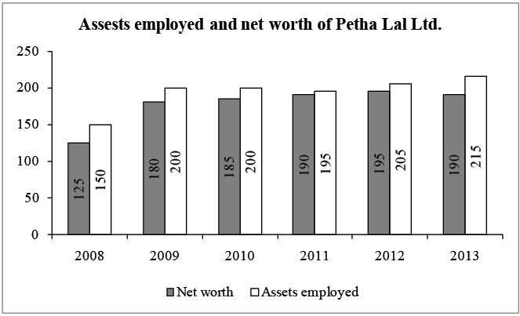

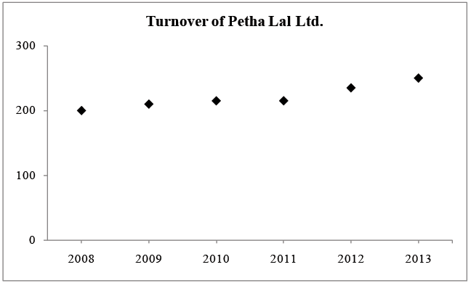

20. If debt taken by Petha Lal Ltd. is equal to the difference between assets employed and net worth, during which year was the debt taken the second highest (for the given period)?

a. 2008

b. 2011

c. 2009

d. 2010

21. Which of the following statements is false?

a. The highest increase in assets employed was between the years 2011 and 2012.

b. The turnover of Petha Lal Ltd. has remained constant from 2010 to 2011.

c. The turnover of Petha Lal Ltd. has never decreased during the period 2008 to 2013.

d. The net worth of Petha Lal Ltd. has continuously increased from 2008 to 2012.

22. If percentage utilisation, then percentage utilisation is maximum in:

a. 2008

b. 2009

c. 2010

d. 2011

**Directions (Q Nos. 23 − 27):** *Go through the chart given below and solve the questions based on it.*

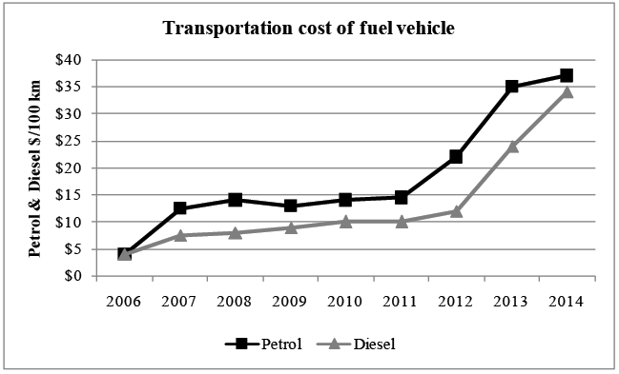

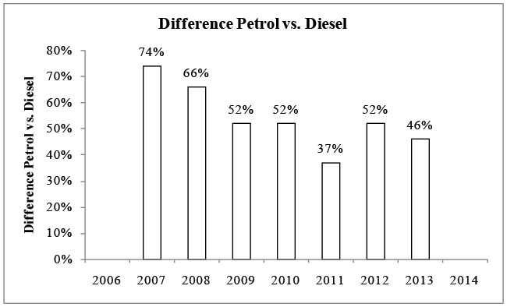

The above charts gives the transportation cost of petrol and diesel verticle in US during the period 2006 to 2014. The cost of petrol is plotted against the Diesel. The difference in the two costs as a percentage of the diesel cost is plotted as a bar chart for the period 2007 to 2013.

23. Which year (between 2006 to 2014) saw the highest difference in the petrol and diesel transportation cost form petrol and diesel (in $/100 km)?

a. 2007

b. 2008

c. 2012

d. 2013

24. Petrol transportation cost was what percentage (on an average) higher than the Diesel transportation cost during the period 2007 to 2013?

a. 9%

b. 32%

c. 54%

d. 75%

25. What is the ratio of the difference in petrol and diesel prices in US in 2009 to the petrol price in US for the same year?

a. 3 : 7

b. 2 : 9

c. 1 : 2

d. Data insufficient

26. Which year showed the highest percentage growth (over the previous year) in the difference of petrol and diesel transportation costs in US during the period 2008 to 2013?

a. 2012

b. 2013

c. 2011

d. Data insufficient

27. Which year showed the least percentage growth over previous year, for diesel transportation cost in US during the period 2007 to 2011?

a. 2008

b. 2009

c. 2010

d. 2011

**Directions (Q Nos. 28 − 32):** *Go through the charts given below and solve the questions based on it. Use approximations wherever necessary.*

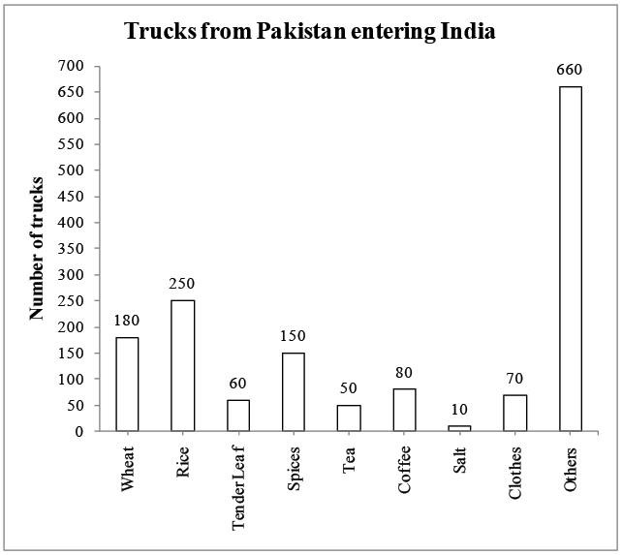

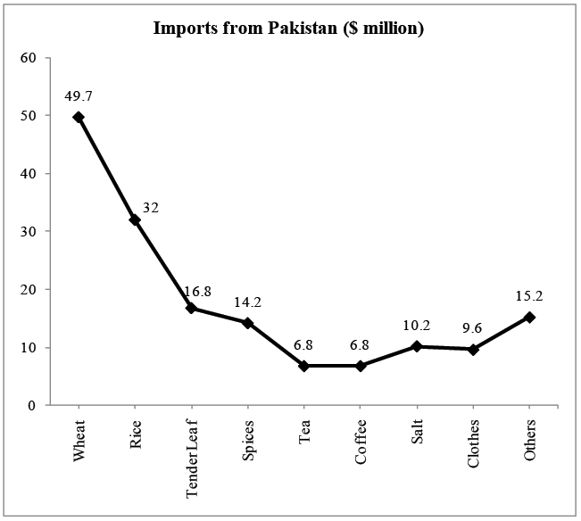

28. What is the difference between the number of trucks under "Others" and all the other trucks?

a. 185

b. 175

c. 180

d. 190

29. A business tycoon made a number of trucks in various categories. Approximately 21% of the spices trucks, 29% of the tea trucks and 37% of the trucks under tender leaf were made by him. The total number of trucks made by him was closest to:

a. 68

b. 90

c. 110

d. 130

30. If multinational companies signed 43% of the trucks under others and on an average, 39% of the trucks in all the remaining categories, what percent of the trucks under others were formed by the trucks in all the remaining categories, if only the trucks signed by multinationals are considered?

a. 100%

b. 126%

c. 116%

d. 106%

31. Considering the data given in question 29, what was the maximum amount invested by the business tycoon (in $ million) and in which industry (if in a particular segment, each truck cost same price)?

a. Tender leaf, 6.216

b. Tender leaf, 5.119

c. Tea, 1.972

d. Spices, 2.982

32. If the Pakistan government promised to make an export of US $ 450000 per truck then what was the percentage shortfall between the actual import and expected import?

a. 66%

b. 76%

c. 84%

d. 86%

**Directions (Q Nos. 33 − 36):** *Go through the chart given below and solve the questions based on it.*

The following pie-chart and table give the details of the scores made in a certain match by the top four batsmen of RCB and all the remaining batsmen of the team, under the title 'Others'. Further, it is known that except Kohli and ABD, no two batsmen who scored any runs, scored the same number of runs in the match. The details of the runs scored by each batsman in 4's and 6's as a percentage of the respective total number of runs made by him are also given. There were no extras in the total score, which, in turn, was not more than 400.

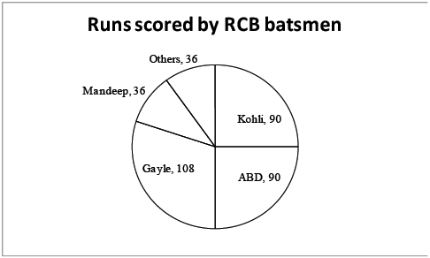

(In the above pie chart the values are in degrees)

|  |  |  |  |
| --- | --- | --- | --- |
| **Percentage of their respective total runs that were scored in 4's and 6's** | | | |
|  | | **(in percentage terms)** | |
| **Players** | **4's** | | **6's** |
| ABD |  | | 40 |
| Gayle |  | |  |
| Mandeep |  | |  |
| Kohli | 40 | | 20 |
| Others |  | |  |

33. What was RCB's total score in the match?

a. 216

b. 144

c. 80

d. None of these

34. The number of 4's scored by Kohli in the match is:

a. 7

b. 8

c. 9

d. 10

35. The total number of 6's scored by India in the match is:

a. 8

b. 9

c. 13

d. 15

36. At most how many players of the India team could have failed to score any runs in the match, given that there were a total of 11 players in the team?

a. 3

b. 4

c. 5

d. 6

**Directions (Q Nos. 37 − 39):** *Go through the charts given below and solve the questions based on it.*

In a survey conducted by E & Y, package given to students in various colleges across India was tabulated. Following graphs show the percentage of students receiving the package and the amount received by them in various colleges.

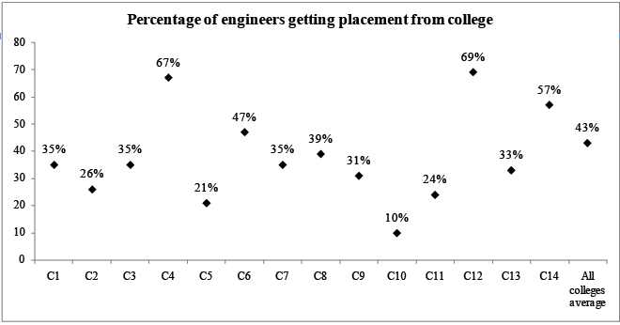

Points on the graph represent each of the given colleges as will as the average of the 14-colleges.

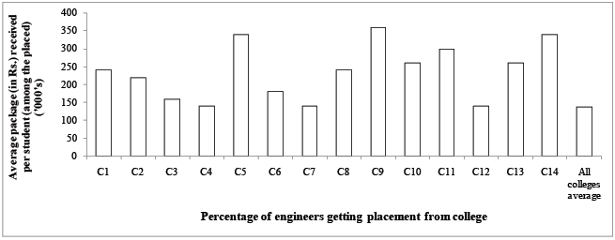

37. What is the average package received by a student in C12?

a. Rs. 1,40,000

b. Rs. 1,75,000

c. Rs. 1,65,000

d. None of these

38. What is the average package received by a student of all those who got placement in C7 and C4?

a. Rs. 1,30,000

b. Rs. 1,35,000

c. Rs. 1,40,000

d. None of these

39. Which of the following is not true?

a. Students of C11 receives lesser average package than students of C5.

b. Students of C1 receives more average package than students of C3.

c. Students of C6 receives more average package than students of C9.

d. None of these

**Practice Exercise – Difficult**

**Directions (Q Nos. 1 − 4):** *Answer the questions based on the following information.*

Coach John sat with the score cards of Indian players from the 3 games in a one-day cricket tournament where the same set of players played for India and all the major batsmen got out. John summarized the batting performance through three diagrams, one for each game. In each diagram, the three outer triangles communicate the number of runs scored by the three top scores from India, where *K*, *R*, *S*, *V*, and *Y* represent Kaif, Rahul, Saurav, Virender, and Yuvraj respectively. The middle triangle in each diagram denotes the percentage of the total score that was scored by the top three Indian scorers in that game. No two players score the same number of runs in the same game. John also calculated two batting indices for each player based on his scores in the tournaments; the R-index of a batsman is the difference between his highest and lowest scores in the 3 games while the M-index is the middle number, if his scores are arranged in a non-increasing order. **[CAT 2010]**

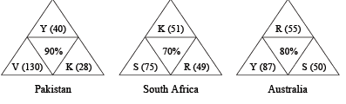

1. For how many Indian players is it possible to calculate the exact M-index?

a. 0

b. 1

c. 2

d. More than 2

2. Among the players mentioned, who can have the lowest R-index from the tournament?

a. Only Kaif, Rahul or Yuvraj

b. Only Kaif or Rahul

c. Only Kaif or Yuvraj

d. Only Kaif

3. How many players among those listed definitely scored less than Yuvraj in the tournament?

a. 0

b. 1

c. 2

d. More than 2

4. Which of the players had the best M-index from the tournament?

a. Rahul

b. Saurav

c. Virender

d. Yuvraj

**Directions (Q Nos. 5 − 8):** *Go through the chart given below and solve the questions based on it.*

Following chart presents the cultivable land scenario in China in different years:

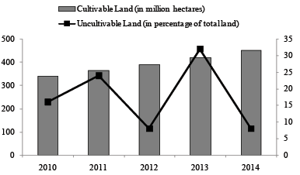

Cultivable land is in the multiples of 10 million and uncultivable land percentage is in the multiples of 10%. Land can be either cultivable or uncultivable.

5. For which of the given years the hectares of uncultivable land is maximum?

a. 2010

b. 2011

c. 2012

d. 2013

6. What is the total land in China in 2011 (approx. in million hectares)?

a. 380

b. 406

c. 424

d. 438

7. For which year, the total land in China in maximum?

a. 2013

b. 2011

c. 2010

d. 2012

8. How many of the following statement/s is/are correct?

I. The total land in China is constantly on a rise during the given period every year.

II. The uncultivable lands is constantly on a rise during the given period every year.

III. The uncultivable land is decreasing every year by at least 10% over the uncultivable land in the previous year.

a. 0

b. 1

c. 2

d. 3

**Directions (Q Nos. 9 − 13):** *Go through the charts given below and solve the questions based on it.*

Chart given below presents the sources of fines collected by teachers and students fines for the year 2013 as a percentage of the total fine.

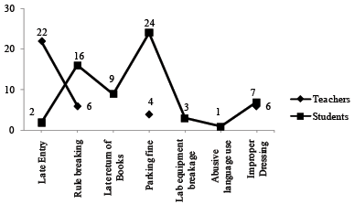

The diagram shown below represents the combined collection of fines by students and teachers (in 000).

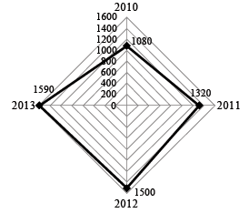

9. Find the difference between the fine generated from parking fine collected by teachers and students in 2013.

a. 318,000

b. 412,000

c. 381,600

d. 349,800

10. What is the total fine generated by the students in 2011?

a. 765,600

b. 792,000

c. 818,400

d. Cannot be determined

11. If fine distribution in 2012 was same as in 2013 and fine from late return of Books was collected for the first time, then what was the percentage increases in fine from source other than late return of Books in 2012 over the previous year?

a. 9.09%

b. 4.56%

c. 10.23%

d. 3.41%

12. Find the compounded annual rate of growth of total fine during 2010-2013.

a. 10.9%

b. 12.3%

c. 13.8%

d. 14.7%

13. What percentage of the total fine collected by teachers is generated from late entry in 2013?

a. 15.12%

b. 22%

c. 56.4%

d. 57.89%

**Directions (Q Nos. 14 − 18):** *Go through the charts given below and solve the questions based on it.*

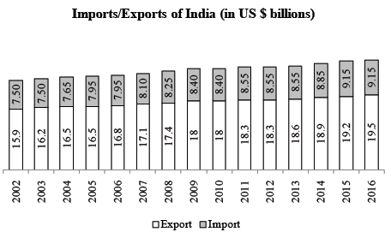

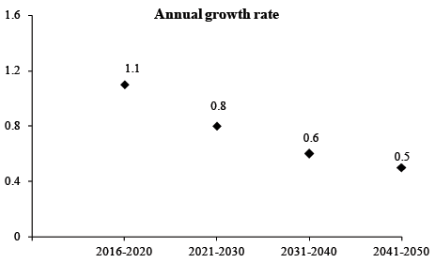

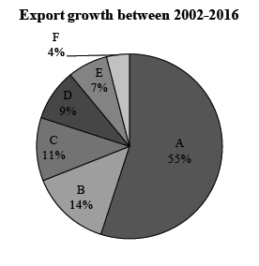

A. Industrial goods

B. Arms

C. Crude Oil

D. Edible Oil

E. Vegetables

F. Foodgrains

14. In the period 2010 to 2016, in which year is the export of India as a percentage of total import/export of India the least?

a. 2011

b. 2006

c. 2007

d. 2013

15. In which 2 years would India's export as percentage of India's total import/export be same?

a. 2006 and 2007

b. 2011 and 2012

c. 2015 and 2016

d. 2008 and 2010

16. In which year in the time period 2000-2050 will India's export be the least?

a. 2010

b. 2000

c. 2030

d. 2040

17. In which year is the imports of India as a percentage of export of India the least?

a. 2010

b. 2008

c. 2009

d. 2013

18. The combined imports and exports of edible oil in 2016 would be:

a. 90 million

b. 92.34 million

c. 86.23 million

d. Cannot be determined

**Directions (Q Nos. 19 − 21):** *Go through the chart given below and solve the questions based on it.*

The scatter charts represent the percentage profit earned by the five companies in years 2010 and 2011. In this chart, the numerical value of the area covered by each of VGS, PLC, Yama, KPMC and NNGT is equal to the percentage profit earned. The companies: Alta Vista, Bultaco, coleco, Dixons and Eletropaulo are disguised in the charts as VGS, PLC, Yama, KPMC and NNGT, in no particular order. The line charts represents the revenue (in rupees crore) of these five companies in year 2010 and 2011.

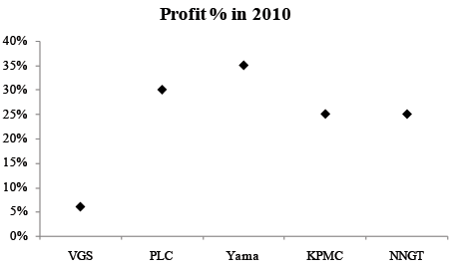

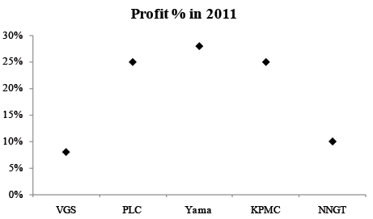

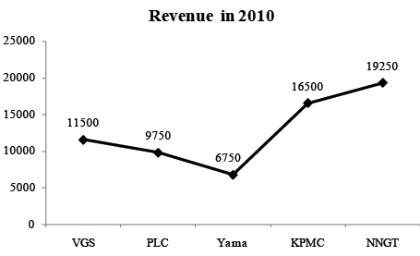

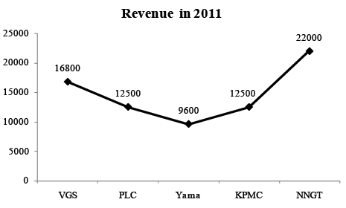

I. Revenue = Expenditure + Profit

Profit % = Total profit × 

II. Among the give companies, "Dixons" earned the minimum profit in both the years 2010 and 2011.

III. Among the five companies, Eletropaulo had the maximum difference between the profit earned in the years 2010 and 2011 profits.

IV. Data of a question can be used in further questions.

19. Among the five companies, Coleco earned the second highest profit in year 2011. Which company earned the highest profit in 2011?

a. Both Alta Vista and Bultaco

b. Both Bultaco and Eletropaulo

c. Both Eletropaulo and Alta Vista

d. Alta Vista

20. Among the five companies, Alta Vista earned the second highest profit in year 2010. From the following choices, identify the name of the company, which earned the second highest profit in 2010?

a. Bultaco

b. Both Coleco and Eletropaulo

c. Eletropaulo and Dixons

d. Both Bultaco and Coleco

21. Which of the following companies had the second highest percentage increase in profit in the year 2011 over 2010?

a. Coleco and Dixons

b. Alta Vista and Dixons

c. Bultaco

d. None of these

**Directions (Q Nos. 22 − 25):** *Go through the chart given below and solve the questions based on it.*

A trader started selling toys from Monday and continued till Thursday. Graph (1) shows the average price (in Rs.) per toy of all the toys sold upto a particular day of the week counting from the toys sold on Monday. For example, the average price per toy of all the toys sold from Monday to Wednesday is 40.

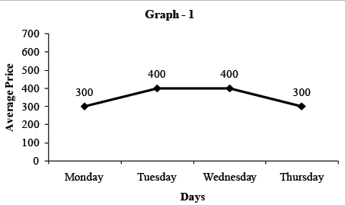

Graph (2) shows the aggregate number of toys sold on (Monday and Tuesday), (Tuesday and Wednesday), (Wednesday and Thursday).

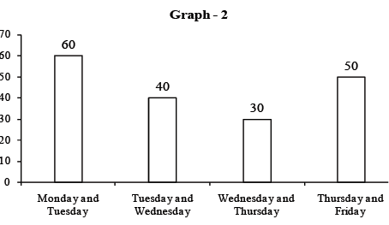

The number of toys sold on any day is a multiple of 10.

In the following questions, mark

**Choice (I),** if the questions can be answered by graph (1) and graph (2) is not required.

**Choice (II),** if the question can be answered by graph (2) alone and graph (1) is not required.

**Choice (III),** if the question can be answered by both the graphs (graph (1) and graph (2)) taken together and not by any one of these graphs alone.

**Choice (IV),** if the question can be answered even by using both the graphs together.

22. What is the average price per toy of all the toys sold on Wednesday?

a. I

b. II

c. III

d. IV

23. What is the total number of toys sold on Tuesday and Thursday?

a. I

b. II

c. III

d. IV

24. Given that no toy was sold on one of these days, which day was it?

a. I

b. II

c. III

d. IV

25. What is the average price per toy of all the toys sold on Thursday?

a. I

b. II

c. III

d. IV

**Directions (Q. Nos. 26** − **30):** The line chart below shows the total number of deaths in the state of TMK due to various diseases in year 2014.

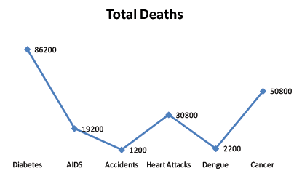

The bar chart below shows the percentage break up these deaths accross various age groups due to these diseases.

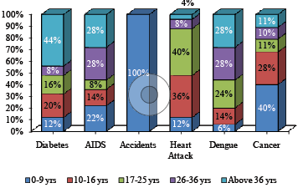

26. Maximum number of deaths were from which age group?

a. 0-9 years

b. 10-16 years

c. 17-25 years

d. Above 36 years

27. In which of the following categories was the number of deaths the highest?

a. Deaths due to diabetes in the age group of 26-36 years.

b. Deaths due to AIDS in the age group of 0-16 years.

c. Deaths due to Dengue.

d. Deaths due to Cancer in the age group of 17-25 years.

28. If the disease wise break up of the total deaths was plotted on a pie chart, then the angle subtended by the sector representing the total deaths due to heart attacks would approximately be how many degrees more than that the sector representing the total deaths due to AIDS?

a. 140

b. 220

c. 280

d. 380

29. In the 0-9 age group, the number of deaths caused by dengue forms what percentage of deaths caused due to heart attacks?

a. 3.57%

b. 7.14%

c. 50%

d. Cannot be determined

30. Which of the following is true?

a. Deaths due to heart attacks in the age group of above 36 years are less than the total deaths due to accidents.

b. Least number of deaths occurred in the 17-25 years group.

c. The percentage of deaths caused by AIDS is 12% of total deaths.

d. The most number of deaths in the 26-36 years age group were caused due to diabetes.

**Directions (Q. Nos. 31** − **35):**The following diagram represents a water system made up of 7 terminals - P to V, connected by network of pipes. The water enters the system only at P and leaves the system from other 6 points. The water (in liters) leaving the system from Q to V and the water flowing through the pipes is shown beside the respected points/pipes.

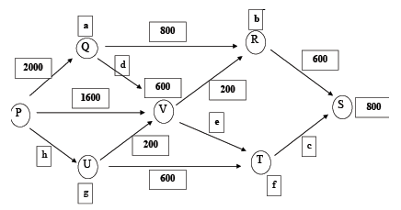

Note: At any point the total water flowing into the system is equal to the total water flowing out of the system.

31. What is the difference between the values of e and d?

a. 200 liters

b. 400 liters

c. 600 liters

d. 800 liters

32. If the total water leaving the system at all the 6 points put together is 5400 liters, then what is the value of *a* + *f*?

a. 1000 liters

b. 1600 liters

c. 2000 liters

d. 2600 liters

33. What is the difference between the values of *e* and *f*?

a. 400 liters

b. 600 liters

c. 800 liters

d. 1200 liters

34. What is the difference between the values of *b* and *c*?

a. 200 liters

b. 800 liters

c. 400 liters

d. 600 liters

35. What is the minimum values of the total water leaving all the 6 points put together?

a. 4400 liters

b. 3200 liters

c. 3600 liters

d. 3800 liters

**Directions (Q. Nos. 36** − **39):** Answer the questions on basis of the information given below.

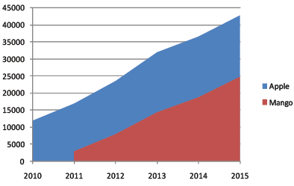

Apple and Mango are two brands of mobiles introduced in 2009 and 2011 respectively. For both these brands exactly 20% of the mobiles bought in a particular year are disposed off after exactly 2 years of their purchase and an equal number are disposed off every following year. It is known that exactly 1000 mobiles of brand Apple were disposed off in 2011. The charts given below shows the number of Apple and Mango mobiles currently in use at the end of each of the 6 years.

36. How many mobiles of Apple were purchased in 2014?

a. 9000

b. 12000

c. 10000

d. Cannot be determined

37. The total number of mobiles of Apple and Mango that were disposed of in 2015 were:

a. 3000

b. 5800

c. 10800

d. Cannot be determined

38. A total of how many mobiles of Apple were disposed off from 2009 to 2013?

a. 5000

b. 5800

c. 3600

d. 7000

39. The number of mobiles of Mango purchased in 2014 was?

a. 6600

b. 5400

c. 4400

d. 6000

**Directions (Q. Nos. 40 − 43):** *Go through the chart given below and solve the questions based on it.*

In the IPL 2015, three awards are to be given at the end of tournament viz. Man of the series, Most valuable player and Emerging player of the series by judging players various parameters. The parameters are Batting, Bowling and Fielding. They consider the scores of the students in Batting, Bowling and Fielding along with Fair play points of their teams. The relative weights of these parameters in awarding these are shown in the following figure.

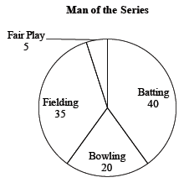

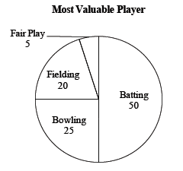

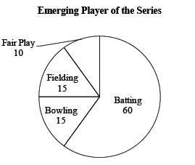

Marks obtained by a few players in these parameters are compiled in the following table.

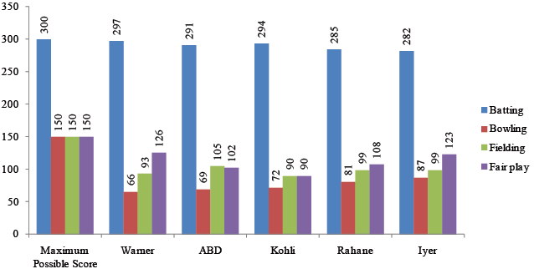

Man of the series, Most valuable player and Emerging player of the series will be shortlisted and short list will have top 2, top 3 and top 3 players vying of those awards respectively.

40. Who among the following will not be shortlisted for any award?

a. Kohli

b. Rahane

c. Iyer

d. Warner

41. If Gayle also joins the list with scores of 288, 78, 102 and 93 in Batting, Bowling, Fielding and Fair play respectively, then for how many awards will he be shortlisted?

a. 0

b. 1

c. 2

d. 3

42. Out of the following, by how much and in which parameter Warner can improve his score in order to be shortlisted for Man of the series?

a. 3 point in Bowling

b. 3 point in Fielding

c. 6 points in Fair Play

d. Any one of the above

43. On the basis of the weights of the selection parameters, the average total score of the given five players expressed as the percentage of the maximum possible score is highest for which of the awards?

a. Man of the series

b. Most valuable player

c. Emerging player of the series

d. Data insufficient

**Directions (Q. Nos. 44 − 47):** *Go through the charts given below and solve the questions based on it.*

The data below show the details about new management interns hired by African Paints from 6 top management institutes of Zimbabwe. Each of the charts shows the number of interns hired, maximum and minimum salary offered in the areas of Marketing and Finance.

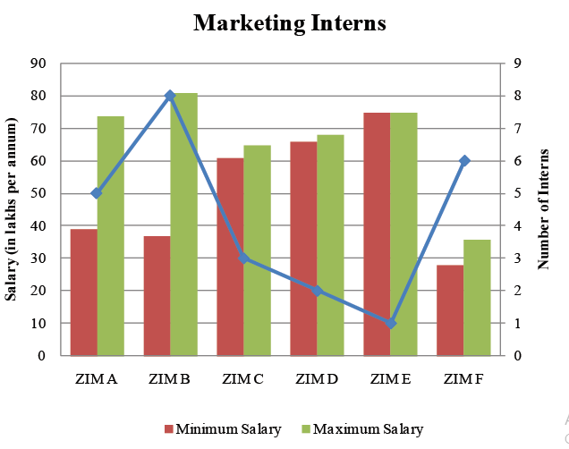

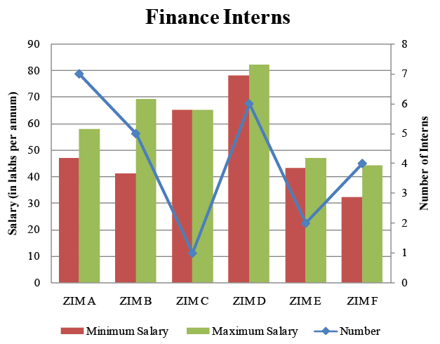

44. What percentage of marketing interns are paid a salary of 50 lakhs per annum or more?

a. 34%

b. 52%

c. 66.67%

d. Cannot be determined

45. What is the least percentage of finance interns who earn a salary of more than 45 lakhs?

a. 30%

b. 64%

c. 90%

d. Cannot be determined

46. The percentage of interns who earn a salary of 45 to 55 lakhs (both inclusive) is at most?

a. 38%

b. 45.54%

c. 74.46%

d. Cannot be determined

47. What can be the least average salary of all the interns taken together?

a. 47.22 lakhs/annum

b. 56.12 lakhs/annum

c. 49.64 lakhs/annum

d. Cannot be determined

**Directions (Q. Nos. 48 − 50):** *Go through the charts given below and solve the questions based on it.*

Following charts show the share of food and beverages companies in Bangladesh in year 2014. The food and beverages business is divided into 2 categories i.e. food sales and beverages sales. The charts show break up various players as a percentage of total sales.

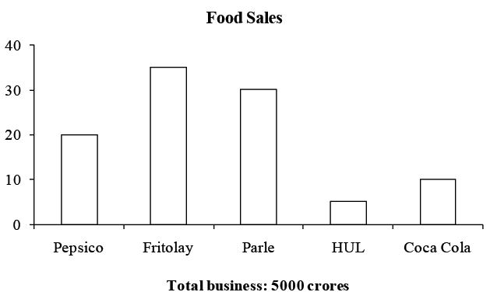

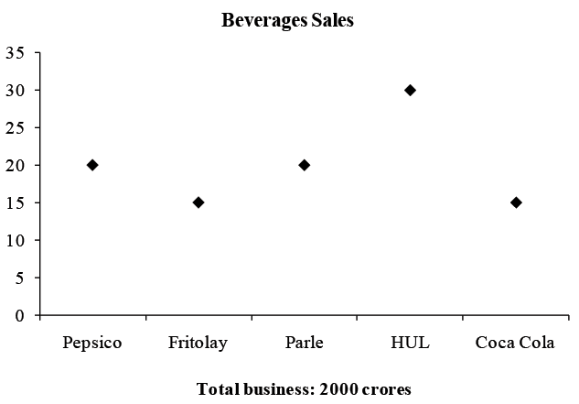

● All items are sold through supermarkets, stores or online. Sales through supermarkets are channel sales and thourgh stores or online are retail sales.

● All beverages are sold through retail sales only.

● Of the total retail sales, 60% is sold though stores.

● HUL sells all its products only through retail sales.

● HUL has 17% of all the business of retail sales.

48. Of the Food sales, what is the ratio of business catered by Channel Sales to the catered by Retail Sales?

a. 8 : 3

b. 2 : 3

c. 4 : 5

d. None of these

49. If the Retail Sales accounted 1500 crores of Fritolay's Food sales, which company has the highest m arket share of the aggregate Retail Sales?

a. HUL

b. Fritolay

c. Parle

d. Cannot be determined

50. If Parle buys Coca Cola and forms a new group "Stay Healthy" by merging the two businesses together, then, of the beverages sales of this newly formed group, what can be the maximum business done through online?

a. 650 crores

b. 700 crores

c. 750 crores

d. Cannot be determined